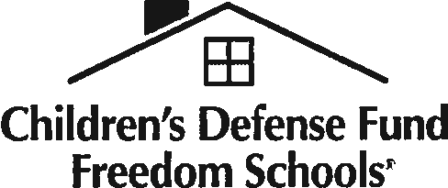Children's Defense Fund Freedom Schools® Program
2018 Servant Leader Intern Application

I. How did you find out about this job opening? -------------------

- Are you a returning servant leader intern? (Circle) Yes No
  - If yes, how many summers have you served as a servant leader intern in the CDF Freedom Schools® program {not including this summer)?
- Were you ever enrolled in the CDF Freedom Schools program as a student participant?
(Circle) Yes No
  - If yes, indicate the year(s) and the CDF Freedom Schools site:-----------
- Do you currently live, or have you ever lived, in the community where this CDF Freedom Schools
site is located? (Circle) Yes No
- Are you are a registered voter? (Circle) Yes No
  - If yes, for how long have you been registered? -------

School Information

I. Highest Education Level Achieved: (check appropriate box)

High School Attending 2-year college Attending 4-year college College Graduate (2-yr.) College Graduate (4-yr.) Attending Graduate School Post-Graduate

2.
College/University City and State

Year in School Current Declared Major

3.
College/University (if applicable) City and State

Dates Attended Major/Degree

- Did you take any education or child development courses in college? (Circle) Yes No

If yes, please list each education or child development course title and the semester the course was taken.

- Have you participated in any leadership development/training courses, classes, seminars, workshops, etc.? (Circle) Yes No

If yes, list the content, date, and place of each training experience.

2017 Ella Baker Child Policy Training Institute • Administrators Manual • 89

Demographic Information

Gender (Circle): Female Male

- Race/Ethnicity (Optional):
Black/African American White Hispanic/Latino Asian/Asian American Native American/American Indian Other (please specify)________________________

- Please indicate the number of individuals in your household (including yourself): _

- Income Information (Optional): Completing chis information will assist the Children's Defense Fund with research related to characteristics of servant leader interns. Please check the box chat matches the range of your family's yearly income:

$0 - 20,000 | $35,000 - 40,000 | $55,000 - 60,000 | $80,000 - 85,000
$20,000 - 25,000 | $40,000 - 45,000 | $60,000 - 65,000 | $85,000 - 90,000
$25,000 - 30,000 | $45,000 - 50,000 | $65,000 - 70,000 | $90,000 - I 00,000
$30,000 - 35,000 | $50,000 - 55,000 | $75,000 - 80,000 | over $100,000

Work and Volunteer Information

Please use additional sheet(s) if necessary.
- Please list any experiences you have had working with children.

- Please list any volunteer and/or paid work you have done in your school, church, or community
(please be specific).

Please describe any work you have done in the area of youth leadership development.

- What knowledge have you gained from your experiences in serving your school, church, or community?

90 • CDF Freedom Schools Program

- Why do you want to work for the CDF Freedom Schools program?

- What special skills or talents will you draw upon and incorporate in your work if selected as a CDF Freedom Schools servant leader intern?

- What are your expectations as a result of your participation with a CDF Freedom Schools site?

- Why should you be selected as a CDF Freedom Schools servant leader intern?

- Are there any factors that will prevent or affect your ability to fully participate in daily program activities?

Emergency Contact

1.
Parent/Guardian Primary Phone

2.
Emergency Contact Person Relationship

Primary Phone Secondary Phone

2017 Ella Baker Child Policy Training Institute • Administrators Manual • 91

